Pamphlet: Bit by Bit – Student Study Space

Page 1 – Introduction

Bit by Bit: A Smarter Way to Study
Bit by Bit is an online study platform designed to help students learn, collaborate, and share knowledge in one place. The website creates a digital study environment where students can access courses, discover study resources, and discuss topics with other learners.
Our goal is to make studying easier and more engaging by giving students a space where they can find helpful information and interact with a community of learners.
The platform allows students to sign in easily using their account and explore different subjects and learning materials. With a clean and simple interface, Bit by Bit makes it easy for students to focus on what matters most — learning.

Why Bit by Bit?
Many students struggle to find organized study resources online. Bit by Bit solves this problem by providing:
- A centralized study platform
- Easy access to multiple subjects
- A community where students can ask questions
- A simple and user-friendly design
Bit by Bit helps students improve their learning step by step — or “bit by bit.”

Page 2 – Features of the Website

1. Easy Login and Access
Students can quickly sign in to the platform using their account. The login page allows users to sign in using their email or other sign-in options, making it simple and convenient to start studying.

2. Course Library
The platform offers different subjects that students can explore, including:
- Physics
- English
- Biology
- Chemistry
- Geography
- Languages
Each subject contains course information and learning material that students can access by clicking “View Course.”

3. Search and Filtering
Students can search for study topics easily using the search bar. They can also filter courses by year or subject to quickly find what they need.
This saves time and helps students focus on the right content.

4. Knowledge Sharing
Bit by Bit also allows students to share knowledge with others. Users can post questions, discuss study topics, and share helpful resources.
This creates a collaborative learning environment where students help each other understand difficult concepts.

Page 3 – Benefits and Conclusion

Benefits for Students
Bit by Bit provides several advantages for students:
Better Organization
Students can find study topics and courses in one place.
Collaborative Learning
Students can interact with others, ask questions, and learn from shared experiences.
Improved Study Efficiency
The platform helps students quickly locate useful learning materials.
Simple and Friendly Design
The website interface is easy to use, making studying less stressful.

Our Vision
Our vision is to build a platform where students can learn together, exchange ideas, and grow academically. By combining structured courses with community discussions, Bit by Bit creates a powerful learning experience.

Few Images of our Website
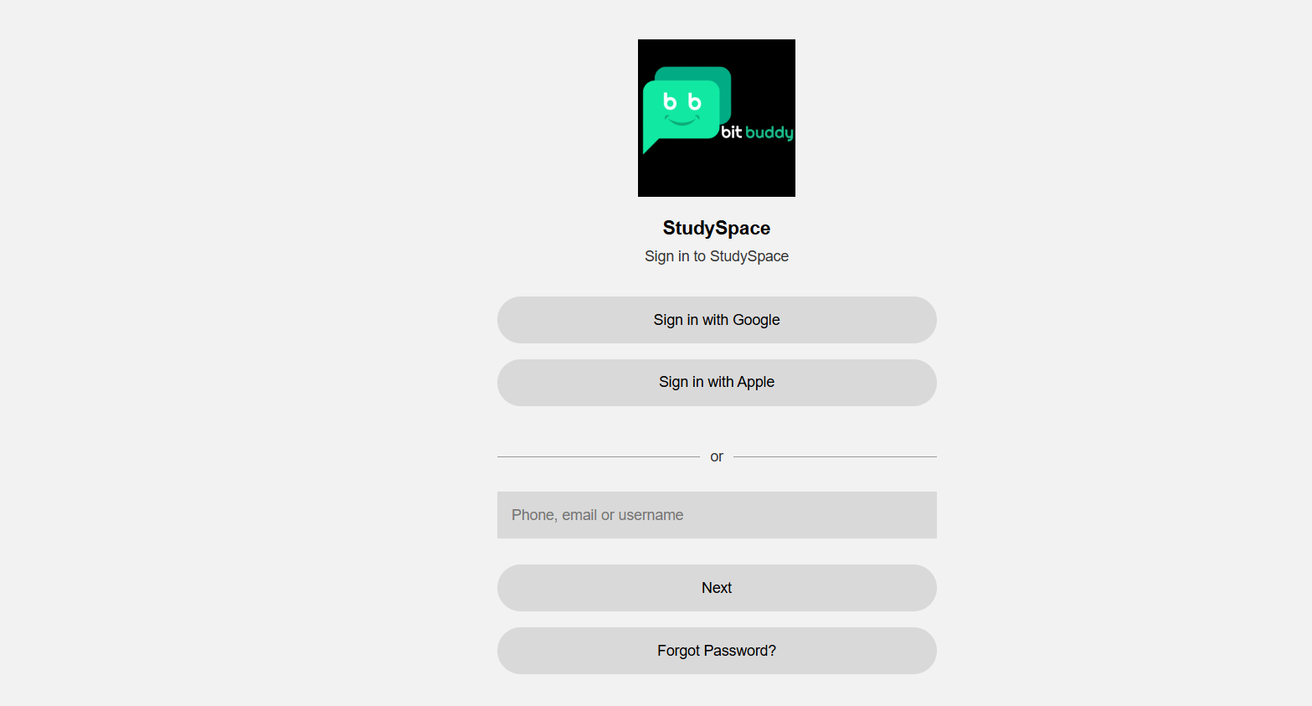

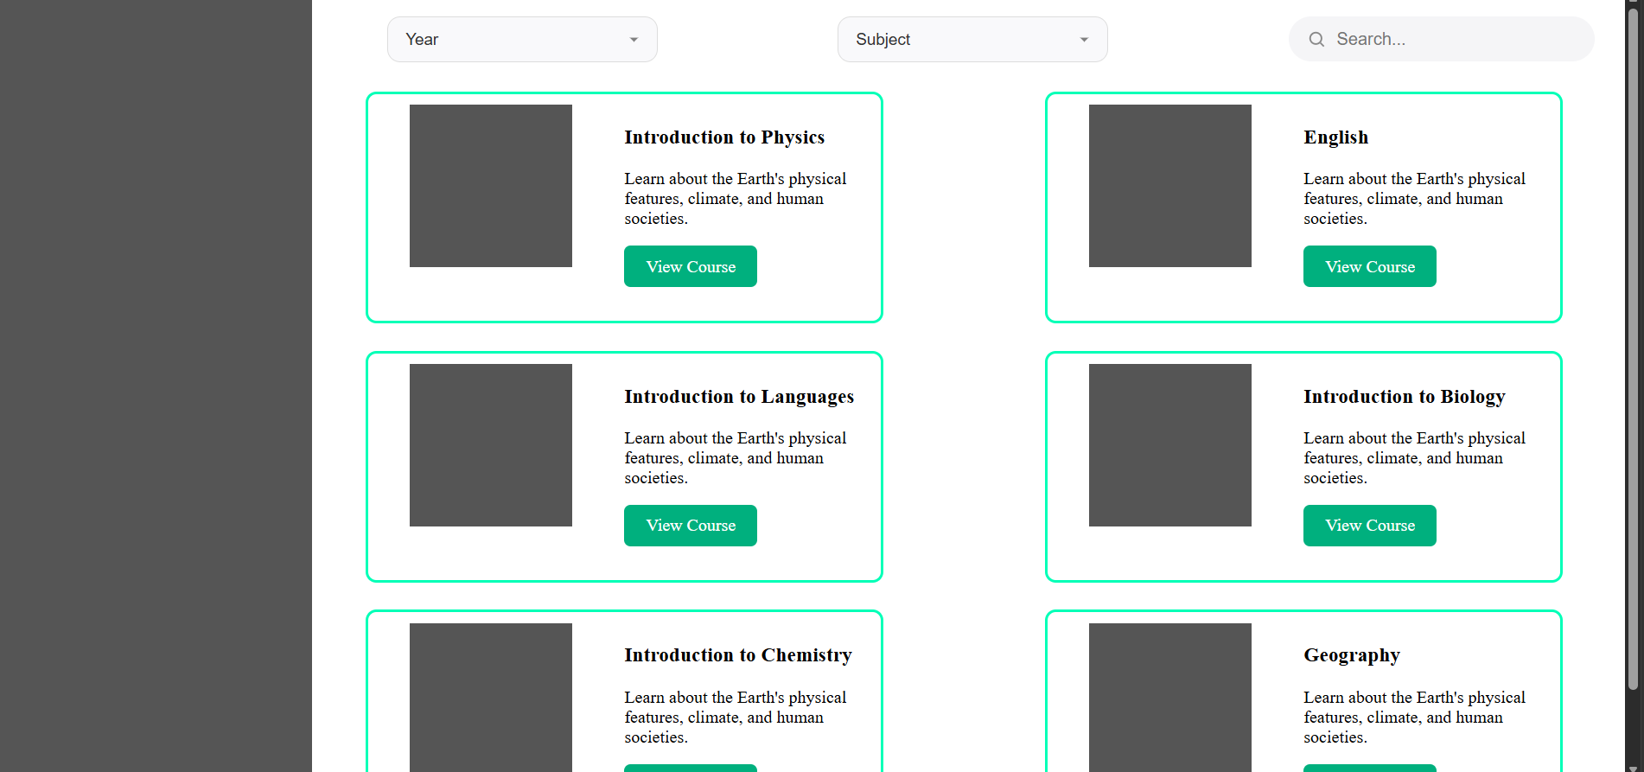

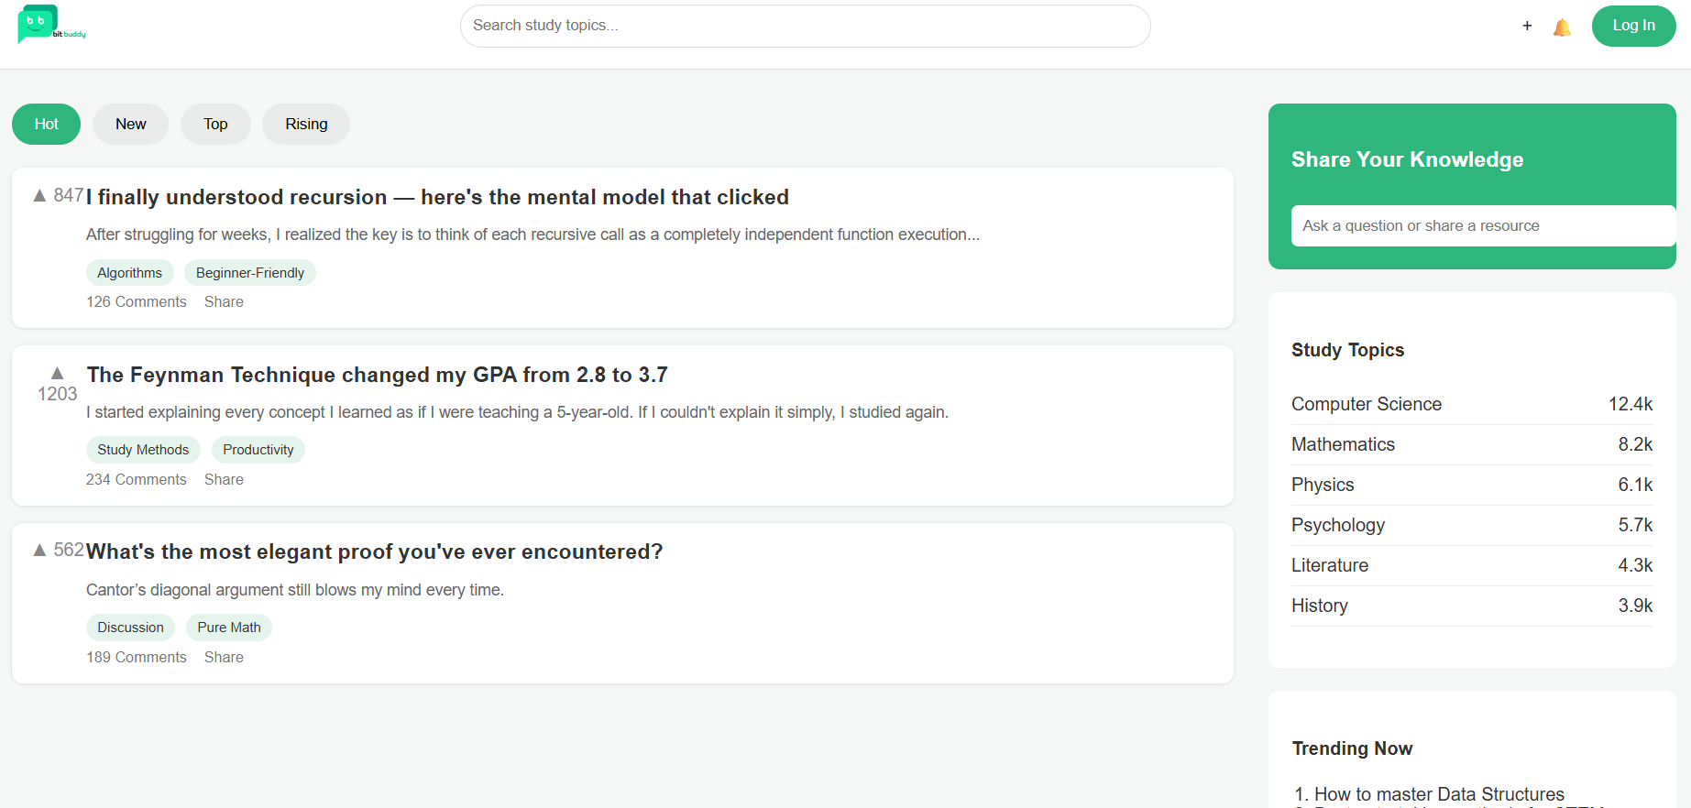

Conclusion
Bit by Bit is more than just a study website. It is a student study space where learners can discover knowledge, share ideas, and improve their understanding of different subjects.
By using Bit by Bit, students can make learning more interactive, collaborative, and effective — one concept at a time.

